1. The Solution is for the phase 1 project program.
2. Git URL :

<https://github.com/Yasser-Alsubhi/Yasir-Alsubhi-JFS-SDA/tree/master/Phase1/Lesson3>

1. Path :

Yasir-Alsubhi-JFS-SDA/Projects/phase1 project/

__________________________________________________________________________________________________

* Copy of the code will be included.
* Also, I include screen shots of the Output.

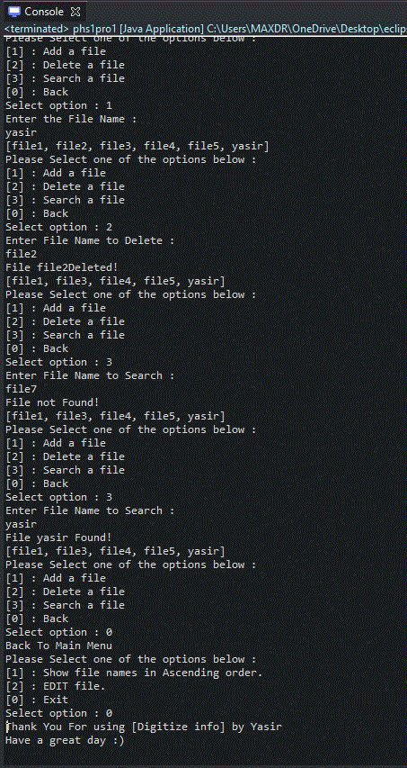

**The flow and features of the application:**

* Planned sprints require to complete the application.

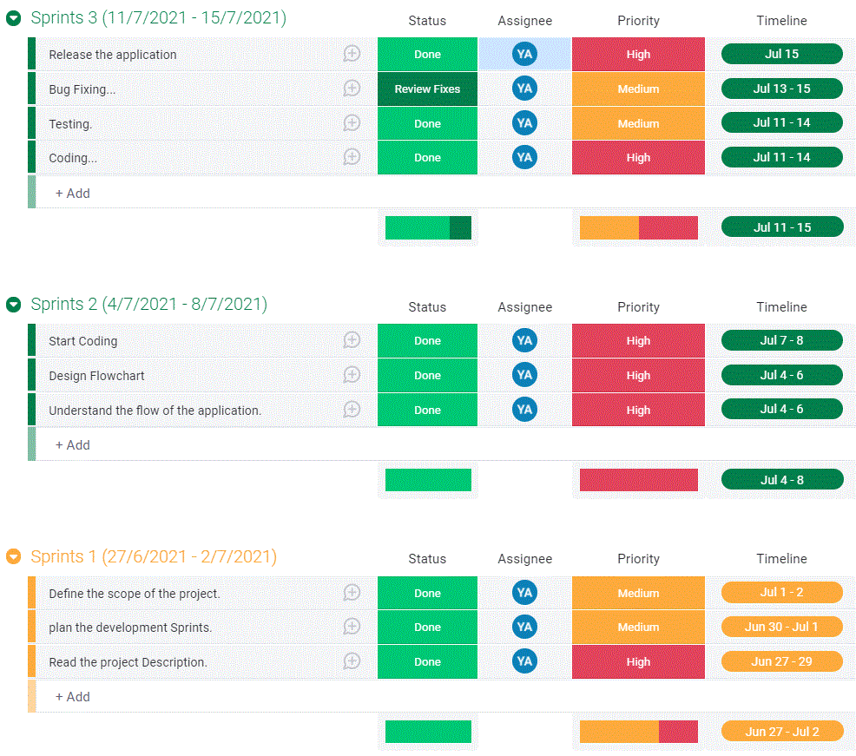

** monday.com used to create it

* Flow of the application:
  + START application.
  + Create a list and insert values.
  + Ask user to select option [1, 2, 0]
    - [1] option is to sort the items list and show it.
    - [2] option is to go to next menu:
      * Ask user to select option [1, 2, 3, 0]
        + [1] option is for ADDING item to the list.

Check if item is there?

YES: print “item Already there!”

NO: ADD item

* + - * + [2] option is for DELETING item from the list.

Check if item is there?

YES: DELETE it

NO: print “item not found!”

* + - * + [3] option is for SEARSHING item in the list.

Check if item is there?

YES: print “item found!”

NO: print “item not found!”

* + - * + [0] option is for go back to main menu.
    - [0] option is for exiting the application.
  + END application.
* Flow chart:

* concepts and algorithms used for this application:
  + LIST
  + Scanner
  + Exception
  + Switch
* Code:

package phase1project1;

import java.util.Scanner;

import java.util.ArrayList;

import java.util.Collections;

import java.util.List;

////////////////////////////////////////////////////////////////////////////////

public class phs1pro1 {

public static void main(String[] args) {

Scanner in = new Scanner(System.in);

int choose1 ;

int choose2 ;

String input ;

System.out.println("[Digitize info] by Yasir");

System.out.println("[Email:Yasser.s.alsubhi@gmail.com]");

System.out.println("__________________________________");

System.out.println("[Digitize info]");

List<String> list = new ArrayList<String>();

list.add("file3");

list.add("file5");

list.add("file2");

list.add("file1");

list.add("file4");

try {

do{

// level 1 options

System.out.println("Please Select one of the options below :");

System.out.println("[1] : Show file names in Ascending order.");

System.out.println("[2] : EDIT file.");

System.out.println("[0] : Exit");

System.out.print("Select option : ");

choose1 = in.nextInt();

switch(choose1) {

case(1):

Collections.sort(list);

System.out.println(list);

break;

case(2):

do{

System.out.println("Please Select one of the options below :");

// level 2 options

System.out.println("[1] : Add a file");

System.out.println("[2] : Delete a file");

System.out.println("[3] : Search a file");

System.out.println("[0] : Back");

System.out.print("Select option : ");

choose2 = in.nextInt();

switch(choose2) {

case(1):// Add item to the list

System.out.println("Enter the File Name : ");

input = in.next();

// check if the item is there in the list

if (list.contains(input))

System.out.println("Item is alredy in the list!");

else

list.add(input);

System.out.println(list);

break;

case(2):// Delete a file from the list

System.out.println("Enter File Name to Delete : ");

// get the file name from the user

input = in.next();

//check if the file name is there in the list

if (list.contains(input)) {

list.remove(input);

System.out.println("File "+input+" Deleted!");

}

else

System.out.println("File not Found!");

System.out.println(list);

break;

case(3):// Search a file from the list

System.out.println("Enter File Name to Search : ");

// get the file name from the user

input = in.next();

//check if the file name is there in the list

if (list.contains(input)) {

System.out.println("File "+input+" Found!");

}

else

System.out.println("File not Found!");

System.out.println(list);

break;

}

}while (choose2 !=0);

System.out.println("Back To Main Menu");

}

}while (choose1 !=0);

System.out.println("Thank You For using [Digitize info] by Yasir\nHave a great day :) ");

System.exit(0);

} catch (Exception e) {

System.out.println("Wrong Input!!");

}

}

}